String’s &functions

**Strings**:-

*• A string is a sequence of characters that is treated as a single data Item.*

*• C does not support string as a data type, instead it allows us to represent strings as character arrays.*

*• A string can be defined as one dimensional array of characters terminated by a null character ‘10’.*

*• These are often used to create meaningful and readable programs.*

*• For example: The string “hello world” contains 12 characters including \0’ character which is automatically added by the compiler at the end of the string. i.e., the size should be equal to the maximum number of characters in the string plus one.*

*• Here, “c string tutorial” is a string.*

*O When compiler encounters strings, it appends a null character ‘\0’ at the end of the string.*

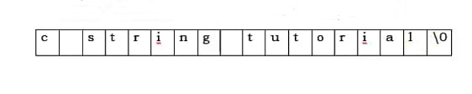

**String Handling Functions:-**

*• C language supports a large number of string handling functions that can be used to carry out many of the string manipulations.*

*• These functions are packaged in string.h library.*

*• Hence, you must include string.h header file in your program to use these functions.*

*•The following are the Most Commonly Used String Handling Functions.*

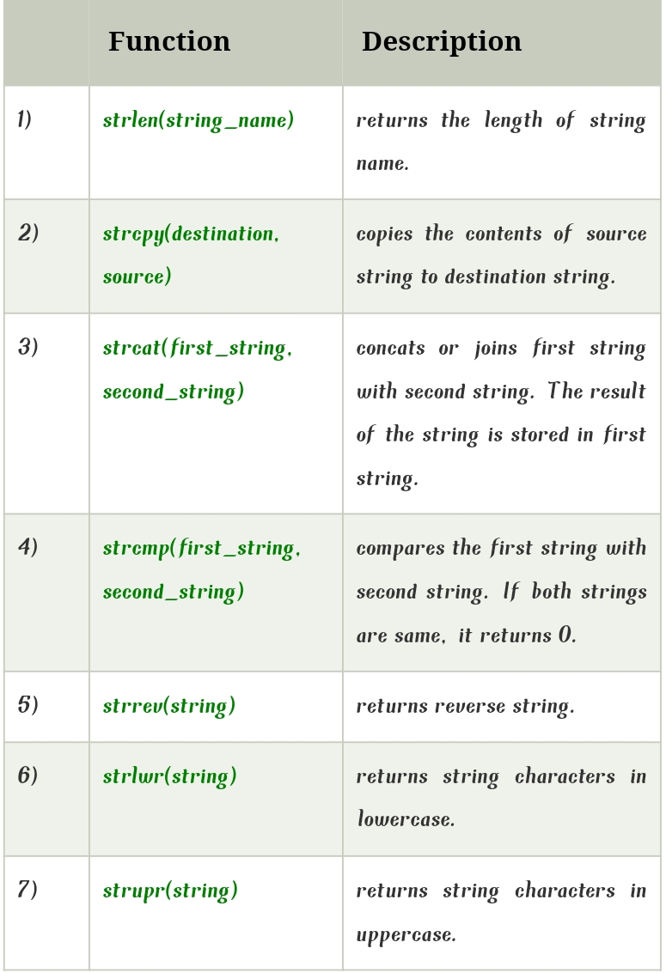

1;**Strcat() :-**

*The strcat() function concatenates string2 to string1 and ends the resulting string with the null character. The strcat() function operates on null-ended strings. The string arguments to the function should contain a null character (\0) that marks the end of the*

String.

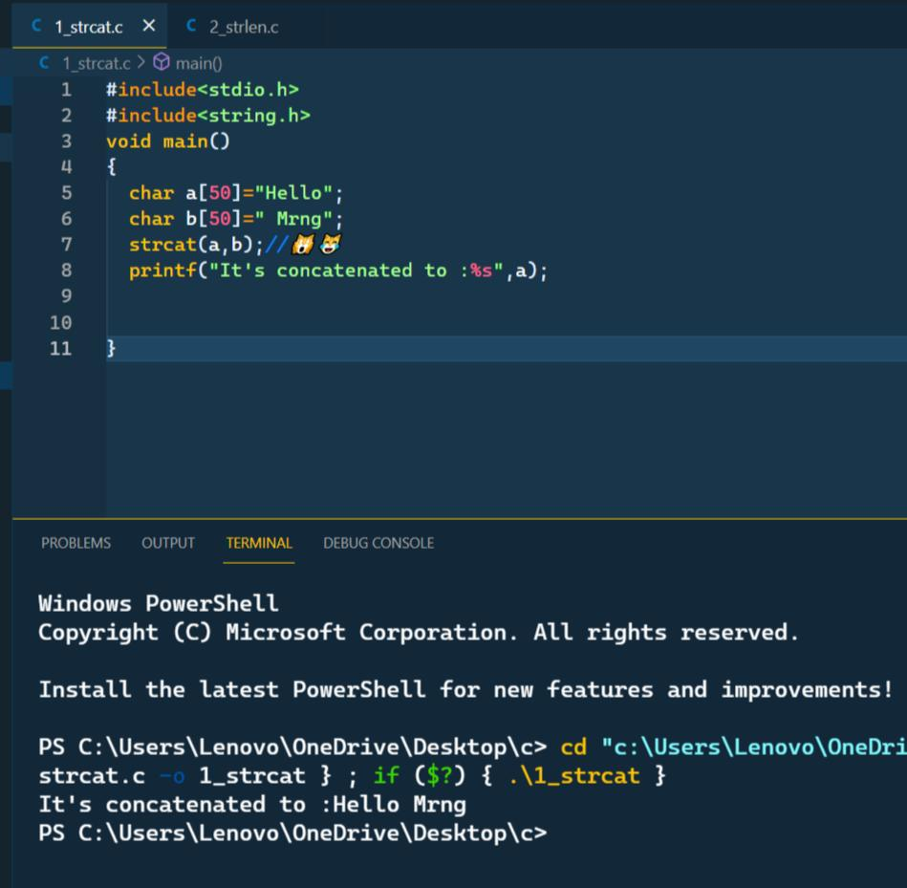

**2;Strlen() :-**

*The strlen() function calculates the length of a given string. The strlen() function takes a string as an argument and returns its length. The returned value is of type size_t (the unsigned integer type). It is defined in the <string. H> header file.*

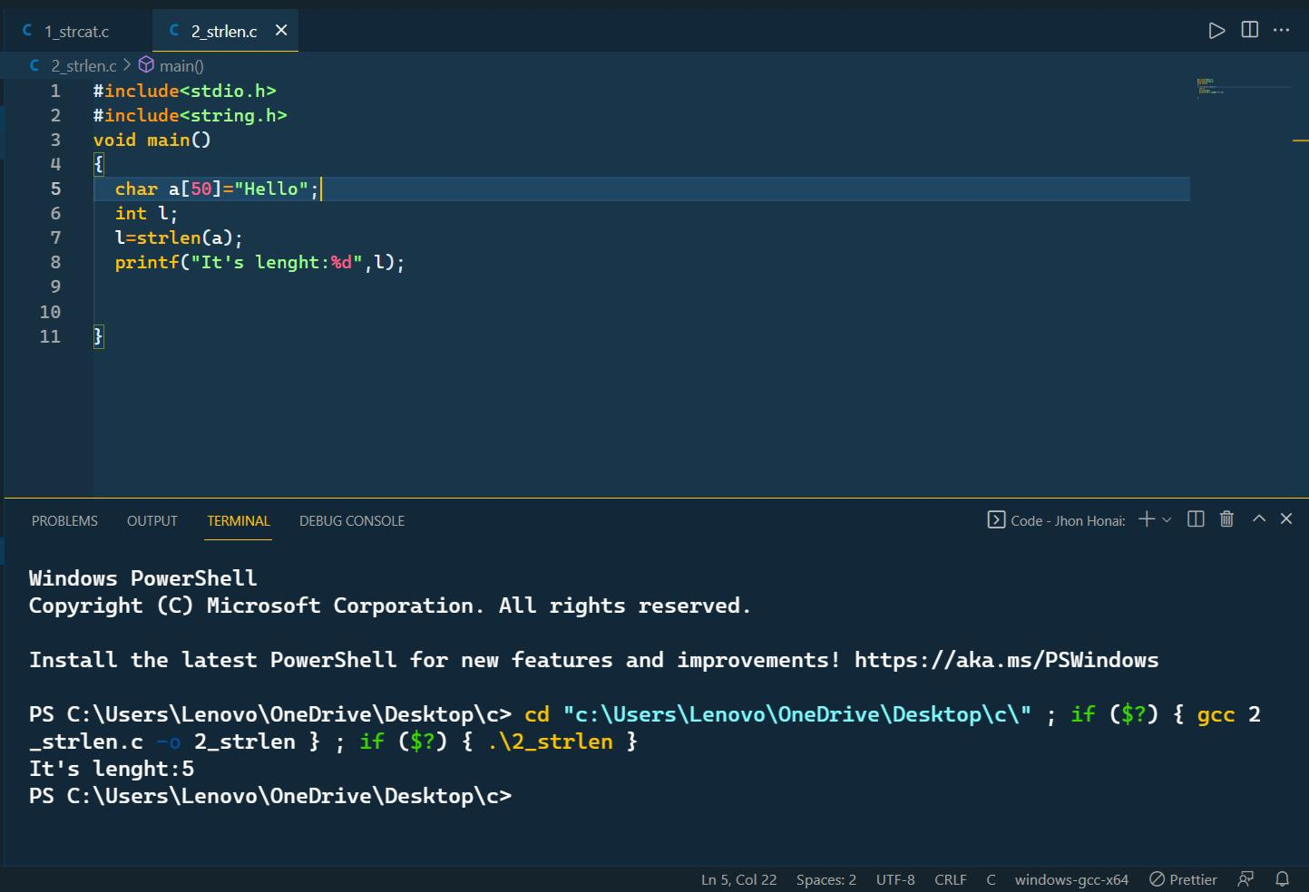

**3;Strrev() :-**

*Strrev() function in C*

*The strrev() function is used to reverse the given string. Syntax: char *strrev(char *str); Parameter: str: The given string which is needed to be reversed*

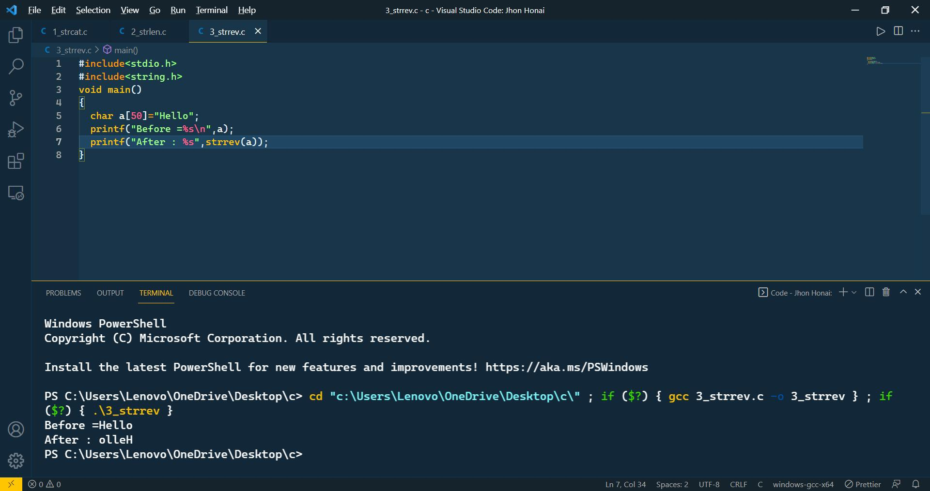

**4;strcpy() :-**

*Strcpy() is a standard library function in C/C++ and is used to copy one string to another. In C it is present in string.*

*. Syntax: char* strcpy(char* dest, const char* src);*

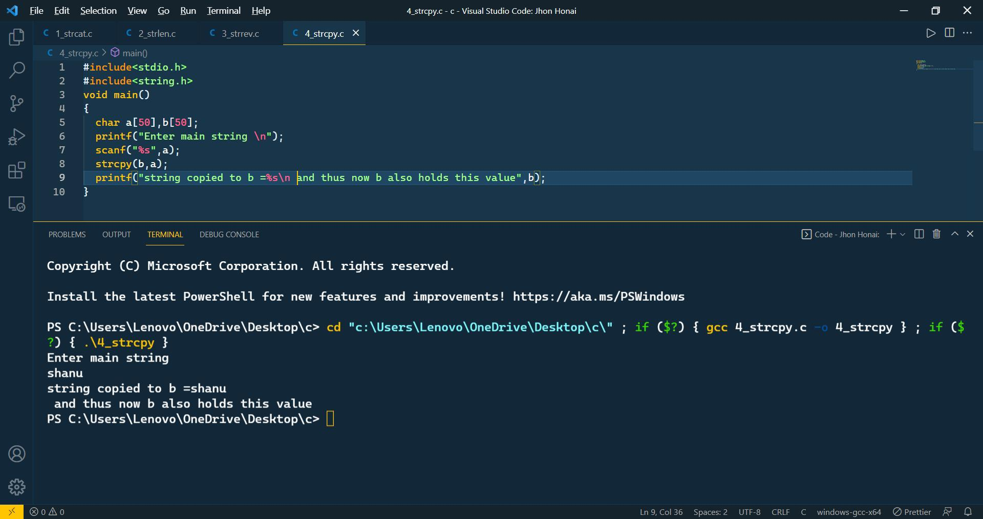

**5;strcmp() :-**

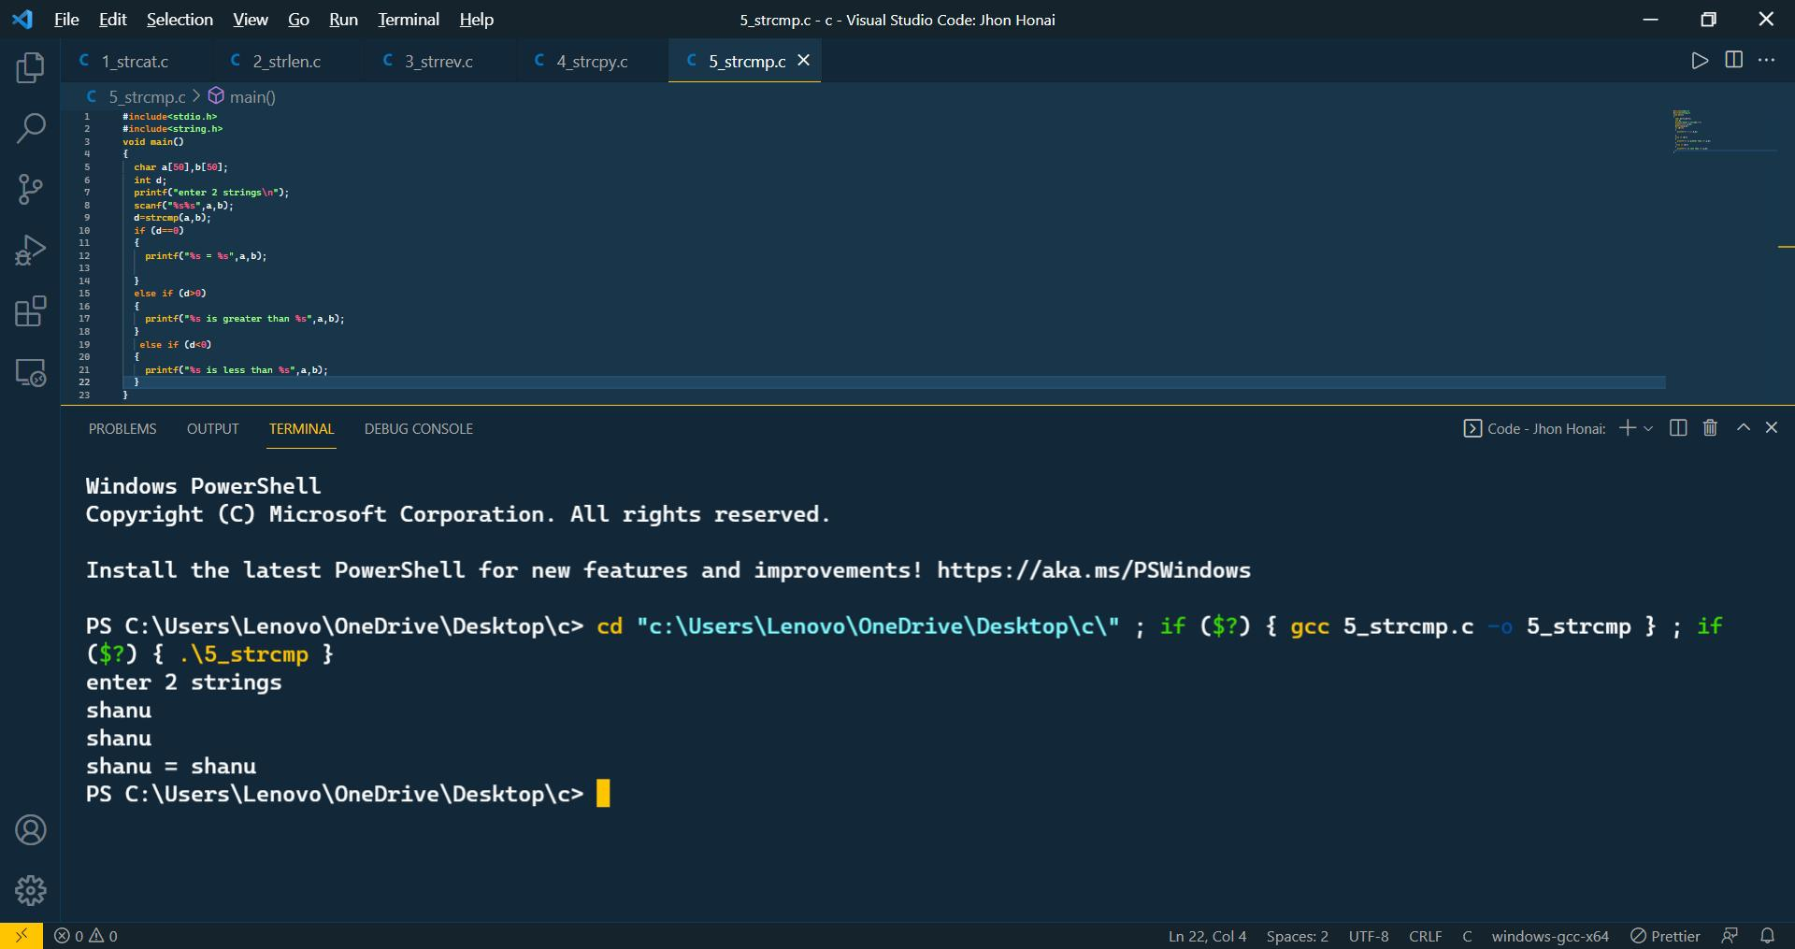

*This function is used to compare the string arguments. It compares strings lexicographically which means it compares both the strings character by character. It starts comparing the very first character of strings until the characters of both strings are equal or NULL character is found.*

**6;strlwr() :-**

*The strlwr( ) function is a built-in function in C and is used to convert a given string into lowercase. Syntax: char *strlwr(char *str); Parameter: str: This represents the given string which we want to convert into lowercase.*

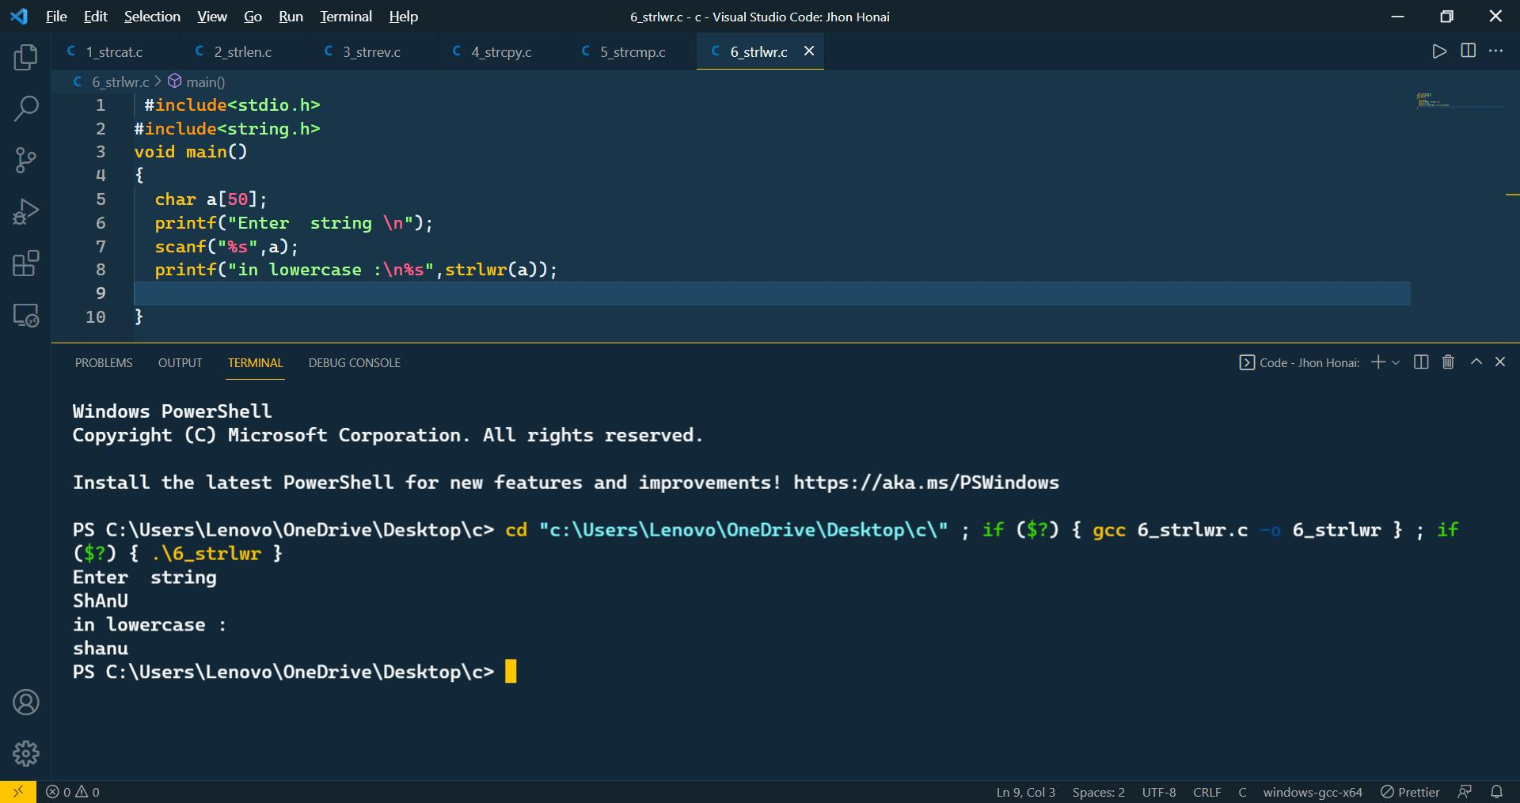

**7;Strupr() :-**

*The strupr( ) function is used to converts a given string to uppercase. Syntax: char *strupr(char *str); Parameter: str: This represents the given string which we want to convert into uppercase.*

